1. Question :

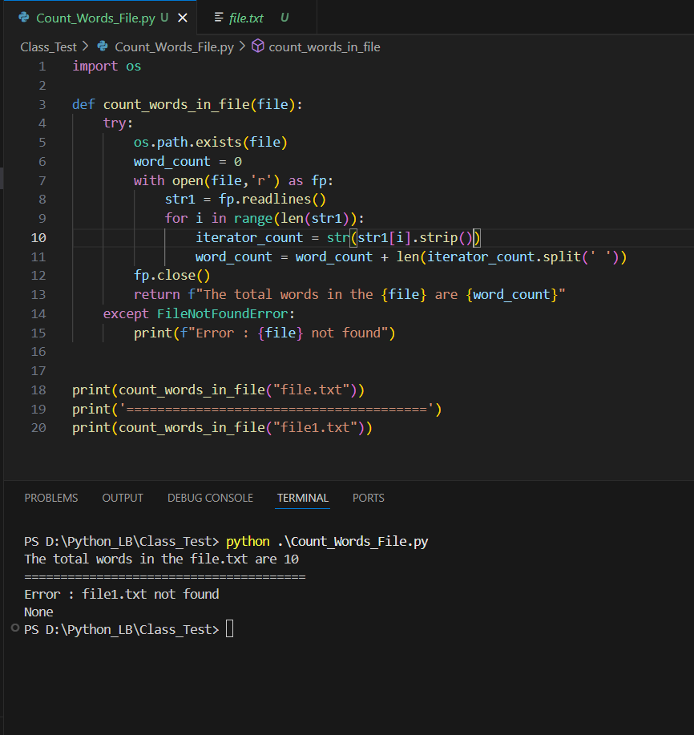Write a Python function called count_words_in_file(filename) that opens a text file, reads its content, and returns the total number of words in the file. If the file doesn’t exist, the function should return the string “File not found”.

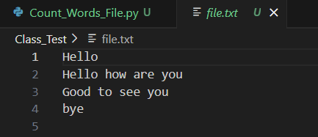

1. Question :

Write a function safe_divide(a,b) that divides two numbers and return the result. If division by zero occurs, catch the exception and return “Cannot divide by zero”. If the input are not numbers (int or float), catch the exception and return “Invalid input”.

Sample test :

1. Safe_divide(5,0) ==> exception will be “Cannot divide by zero”
2. Safe_divide(‘x’,5)==>exception will be “Invalid Input”

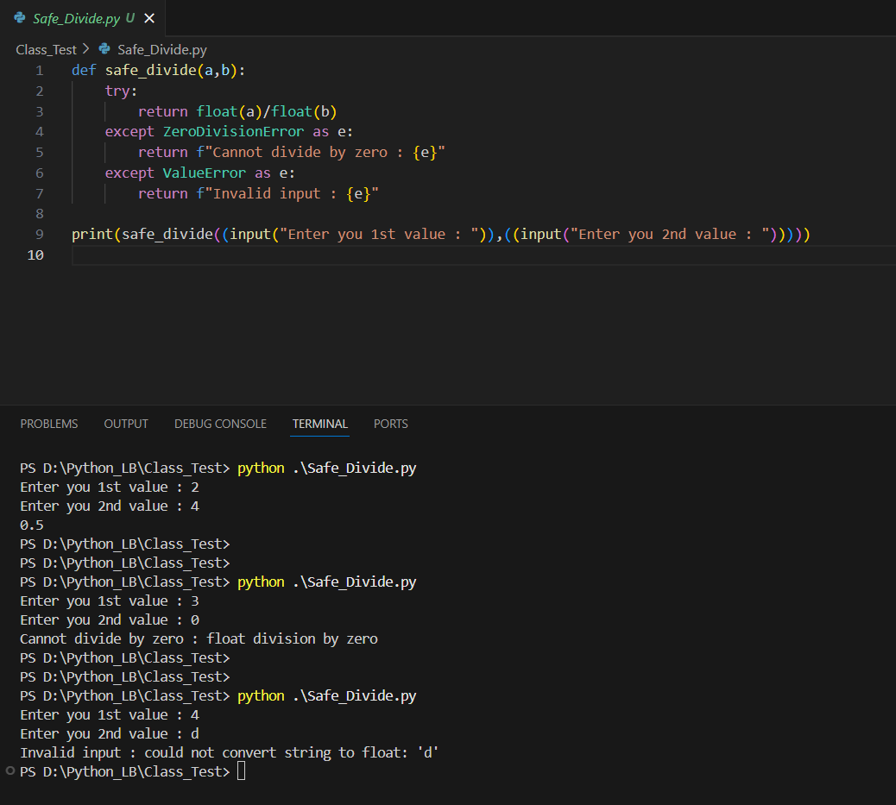

1. Question :

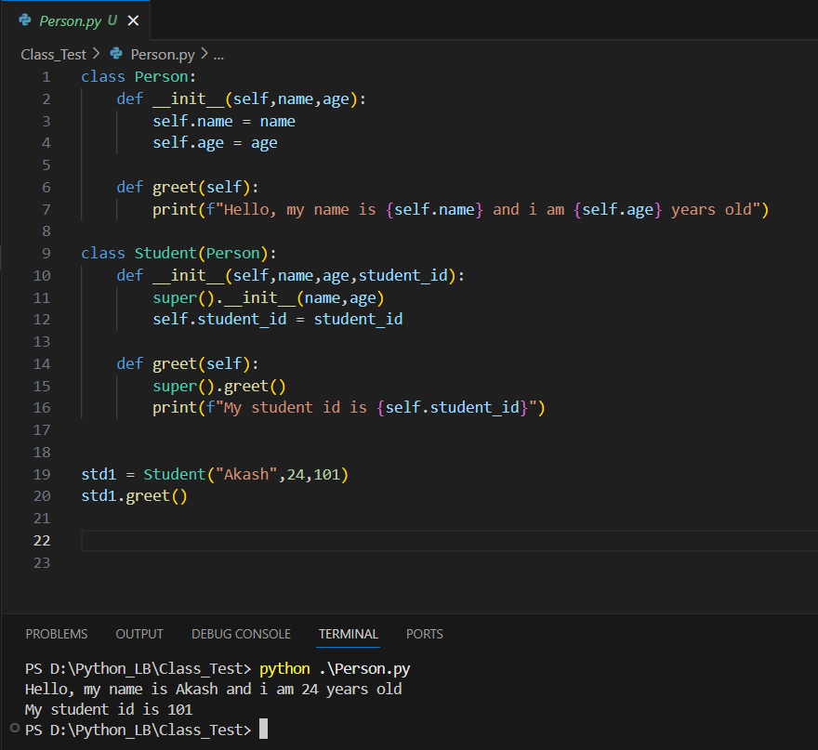Create a class Person with attributes name and age, and a method greet() that prints “Hello, my name is <name> and I am <age> years old.” Then, create a subclass student that inherits from Person and adds an additional attribute student_id. Override the greet() method in Student to also print “Mu Student ID is <student_id>.” Write code to demonstrate the use of both classes.